

<<Project name>>
Software Design Specification

– Hanoi, August 2022 –

Record of changeS
Date | A*  M, D | In charge | Change Description
*A - Added M - Modified D - Deleted

Table of Contents
I. Overview 4
1. Code Packages 4
2. Database Design 4
a. Database Schema 4
b. Table Description 5
II. Code Designs 5
1. Student & Recruitment (Apply Job) 5
a. Class Diagram 6
b. Class Specifications 6
c. Sequence Diagram(s) 7
d. Database Queries 7
2. Student & Recruitment (Create Interview Schedule) 7
a. Class Diagram 8
b. Class Specifications 8
c. Sequence Diagram(s) 9
d. Database Queries 9
3. Training & OJT Process (Approve Official OJT List) 9
a. Class Diagram 9
b. Class Specifications 9
c. Sequence Diagram(s) 10
d. Database Queries 10
4. Training & OJT Process (Review Weekly Report) 10
a. Class Diagram 11
b. Class Specifications 11
c. Sequence Diagram(s) 12
d. Database Queries 12
5. Training & OJT Process (Export Final Grade Report) 12
a. Class Diagram 13
b. Class Specifications 13
c. Sequence Diagram(s) 14
d. Database Queries 14

I. Overview

1. Code Packages
[Provide the package diagram for each sub-system. The content of this section including the overall package diagram, the explanation, package and class naming conventions in each package. Please see the sample & description table format below (please note: package names don’t follow Java package naming convention yet)]
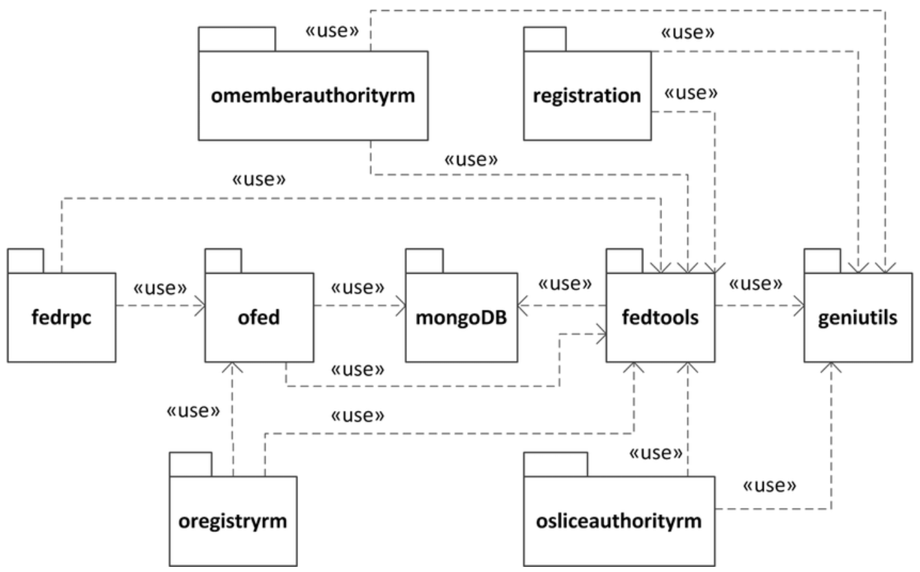
Package descriptions
No | Package | Description
01 | omemberauthorityrm | <Description of the package>
02 | registration | <Description of the package>
03 | fedrpc | <Description of the package>
04 | ofed | <Description of the package>
05 | mongoDB | <Description of the package>
06 | fedtools | <Description of the package>
07 | …

2. Database Design

a. Database Schema
[Provide the tables relationship like example below – following MySQL database naming convention]

b. Table Description
No | Table | Description
01 | <Table name> | <Description of the table>

II. Code Designs

1. Student & Recruitment (Apply Job)
This section describes the detailed design for the Apply Job function. This feature allows students to view a list of internship positions and submit their resumes (CVs) online. The system will receive applications, record their status, and notify the companies.

a. Class Diagram
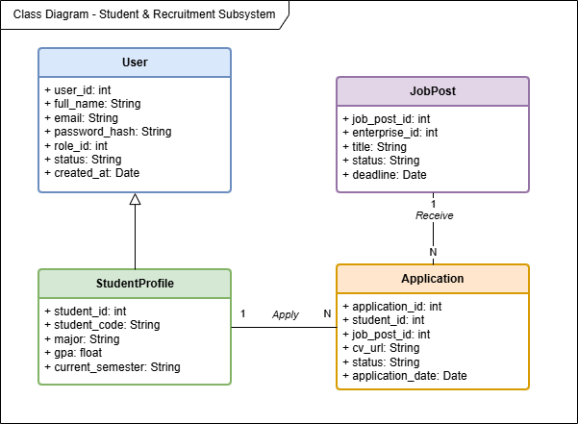

b. Class Specifications

ApplicationController Class
No | Method | Description
01 | createApplication(ApplicationDTO dto) | Receive the payload from the student, convert the DTO to Entity, and call the service to submit the application.
ApplicationServiceImpl Class
No | Method | Description
01 | save(Application entity) | Verify validity (deadline, duplicate applications), save the application and CV snapshot, and update the status to PENDING.

Application Class (Entity)
No | Method | Description
01 | status | Simple states (PENDING, ACCEPTED, REJECTED).

c. Sequence Diagram(s)
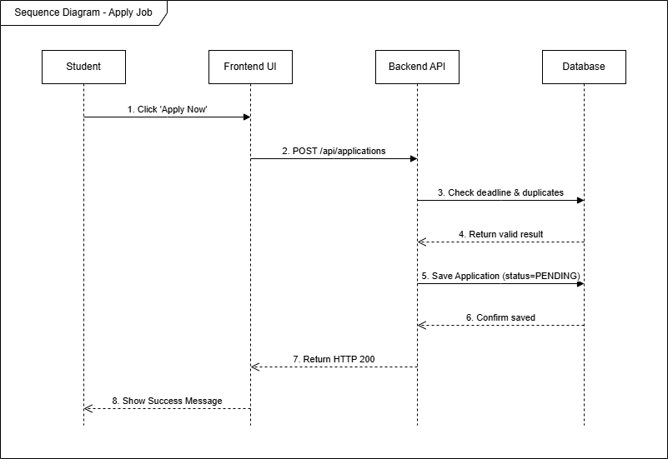

d. Database Queries
SELECT * FROM applications WHERE student_id = ? AND job_post_id = ?;
INSERT INTO applications (student_id, job_post_id, cv_file_url, status, created_at) VALUES (?, ?, ?, ?, ?);

Student & Recruitment (Create Interview Schedule)
This section describes the detailed design for the Create Interview Schedule function. Businesses can select potential applications and set interview times and locations. The system will automatically update the application status and send appointment schedules to students.

a. Class Diagram


b. Class Specifications

InterviewController Class
No | Method | Description
01 | create(InterviewDTO dto) | Receive the payload for scheduling interviews from the company.

InterviewServiceImpl Class
No | Method | Description
01 | save(Interview entity) | Check for scheduling conflicts, update the Application status to INTERVIEW_SCHEDULED, save the interview, and send the email.

c. Sequence Diagram(s)
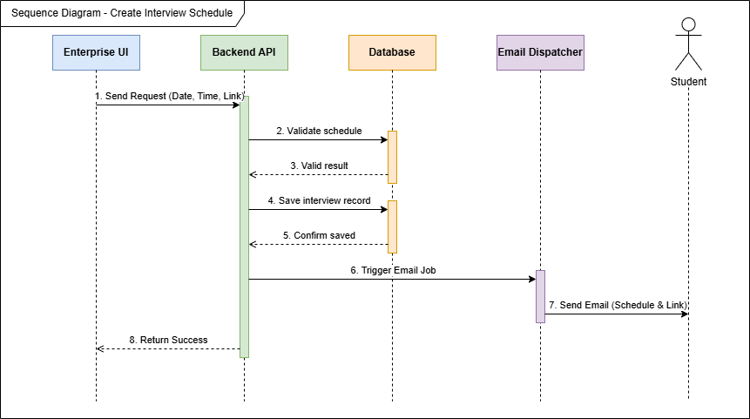

d. Database Queries
SELECT count(*) FROM interviews i JOIN applications a ON i.application_id = a.application_id JOIN job_posts j ON a.job_post_id = j.job_post_id WHERE j.enterprise_id = ? AND i.scheduled_datetime = ?;
UPDATE applications SET status = 'INTERVIEW_SCHEDULED' WHERE application_id = ?;
INSERT INTO interviews (application_id, scheduled_datetime, duration_minutes, location, meeting_link, status, student_confirmed) VALUES (?, ?, ?, ?, ?, ?, ?);

3. Training & OJT Process (Approve Official OJT List)
This section describes the detailed design for the Approve Official OJT List function. This function is used by the Training Manager to confirm and finalize the list of students eligible for on-the-job training (OJT) at the company.

a. Class Diagram

b. Class Specifications

OjtPlacementController Class
No | Method | Description
01 | approvePlacement(UUID id) | Approve students for inclusion in the official internship program.

OjtPlacementServiceImpl Class
No | Method | Description
01 | approve(UUID id) | Update the placement status to APPROVED in the database.

c. Sequence Diagram(s)
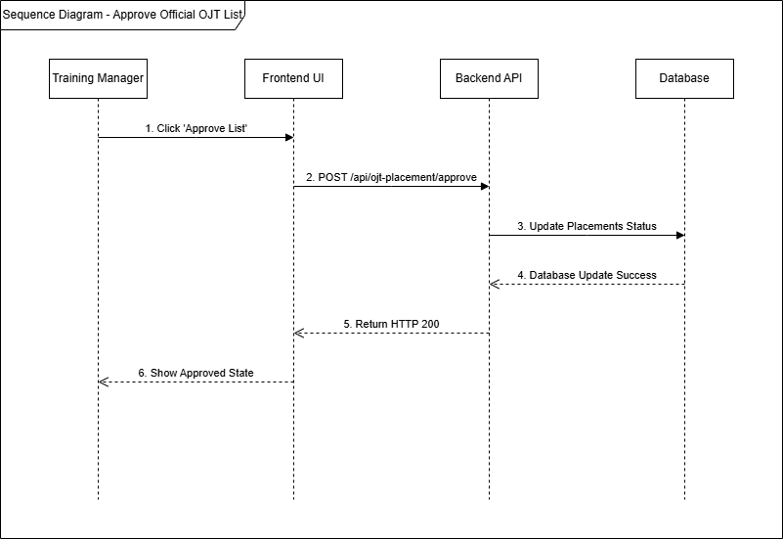

d. Database Queries
UPDATE placement_applications SET status = 'APPROVED', reviewed_by = ?, reviewed_at = CURRENT_TIMESTAMP WHERE application_id = ?;

4. Training & OJT Process (Review Weekly Report)
This section describes the detailed design for the Weekly Report Review function. Students submit weekly progress reports, and the Mentor/Supervisor from the company will review, evaluate, and provide feedback.

a. Class Diagram
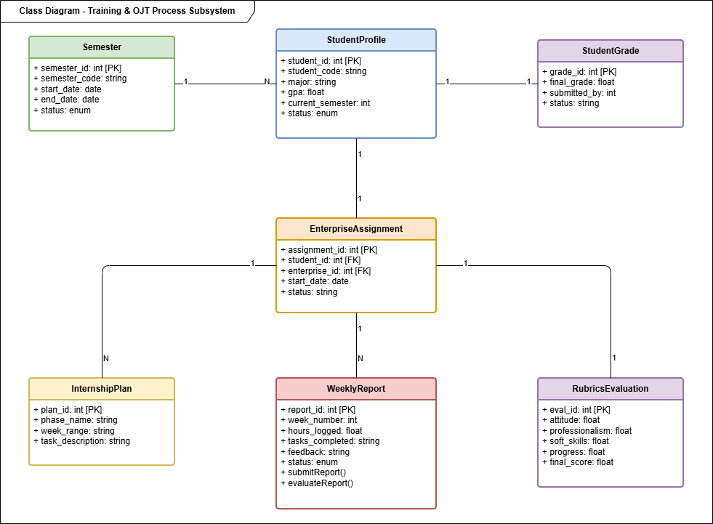

b. Class Specifications

WeeklyReportController Class
No | Method | Description
01 | submitFeedback(FeedbackDTO dto) | Receive feedback from the Mentor on the student's weekly report.

WeeklyReportServiceImpl Class
No | Method | Description
01 | updateFeedback(FeedbackDTO dto) | Save the feedback content and update the report status (REVIEWED).

c. Sequence Diagram(s)
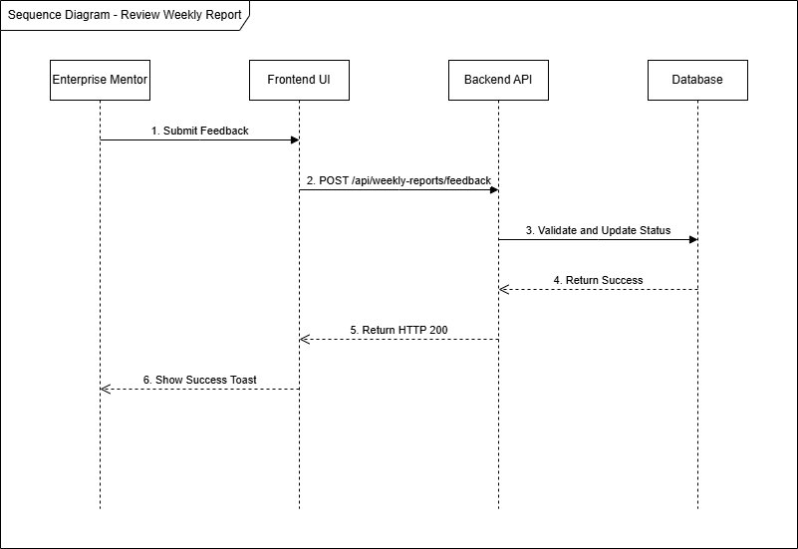

d. Database Queries
INSERT INTO report_feedbacks (report_id, reviewer_id, feedback_text, action, created_at) VALUES (?, ?, ?, 'REVIEW', CURRENT_TIMESTAMP);
UPDATE weekly_reports SET status = 'REVIEWED', updated_at = CURRENT_TIMESTAMP WHERE report_id = ?;

5. Training & OJT Process (Export Final Grade Report)
This section describes the detailed design for the Export Final Grade Report function. The system compiles all internship results and mentor evaluations and exports them to a PDF file containing a list of students' final grades.

a. Class Diagram


b. Class Specifications

FinalGradeController Class
No | Method | Description
01 | exportFinalGradesPdf() | Export the end-of-term report in PDF format.

ExcelExportServiceImpl Class
No | Method | Description
01 | exportFinalGradesPdf() | Retrieve data, create a PDF table using Lowagie iText, and return a ByteArrayOutputStream.

c. Sequence Diagram(s)
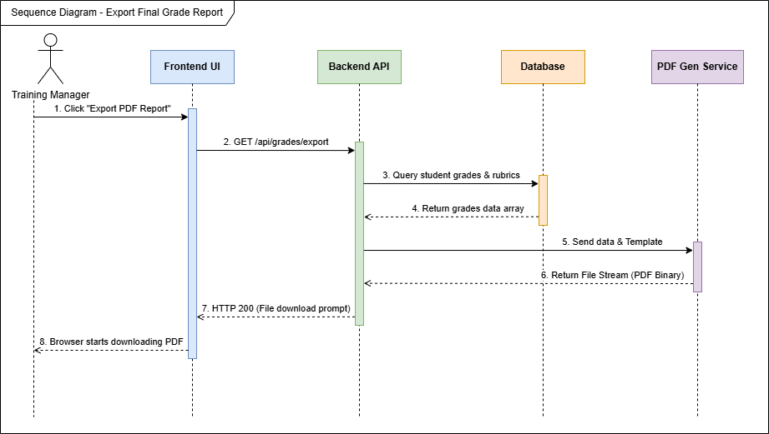

d. Database Queries
SELECT fg.grade_id, fg.final_grade, fg.overall_status, u.full_name, sp.student_code
FROM final_grades fg
JOIN users u ON fg.student_id = u.user_id
JOIN student_profiles sp ON u.user_id = sp.user_id
ORDER BY u.full_name ASC;

